3. Run LDA on these data.

(a) Make a colour plot of the classes against pairs of linear discriminants. The plot()

function will do this for you automatically. Use these colours:

class.col <- ifelse(set1$class==1,y=53,n= ifelse(set1$class==2,y=68,n=

ifelse(set1$class==3,y=203,n=464)))

**Present the plot and write a sentence for each linear discriminant, explaining**

**how it seems to separate classes.**

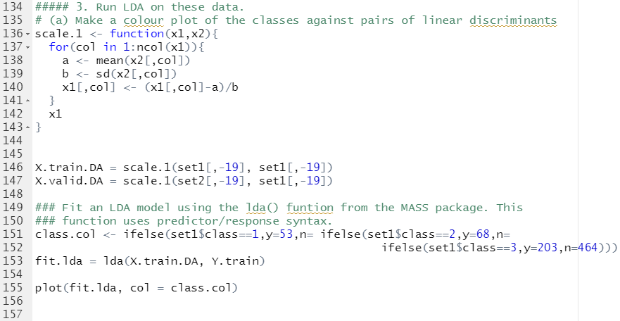

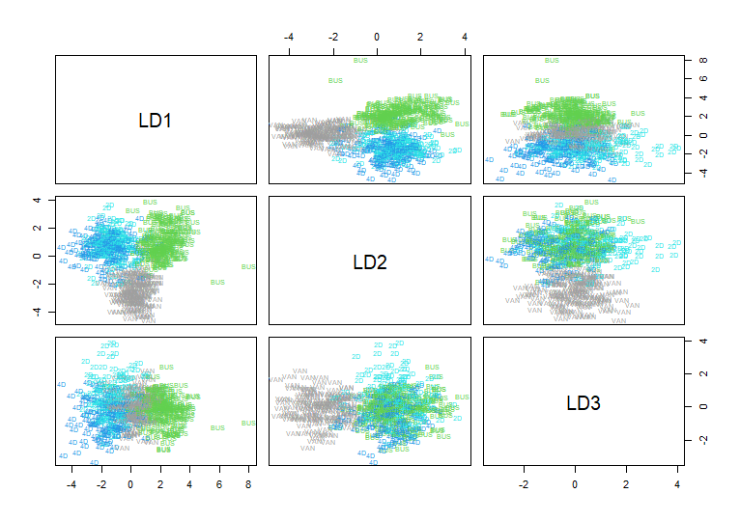

-> It looks like LDA discriminates 3 classes quite well. Some of them are separated horizontally and some of them are separated vertically and so on.

(b) **Report training and test error**. **How does test error compare to other**

**methods?**





So far this shows the best performance.

4. Run QDA on these data. **Report training and test error**. **How does test error**

**compare to other methods?**

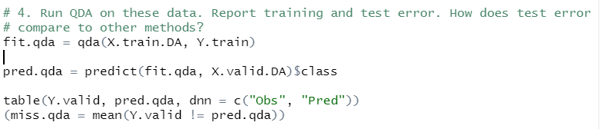



This shows better performance even than LDA. This is due to the fact that quadratic have less bias than linear.